**Chapter 4**

**1. Examine the coordinate system for the streets feature class in the Austin geodatabase.**

The coordinate system for the streets feature class in the Austin geodatabase is NAD1983. It is projected. The map units are Feet

Screenshot:

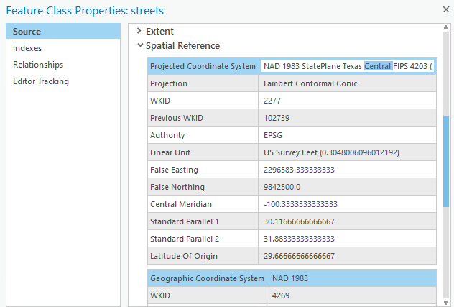

**2. What is the name of the projection (not the coordinate system) used by the feature classes in the Oregon geodatabase?**

The projection used by the feature classes in the Oregon geodatabase is the Lambert Conformal Conic projection. The central meridian is -120.5 and the standard parallel(s) are 43 and 45.5. No, it does not use the equator for the latitude of origin.

Screenshot:

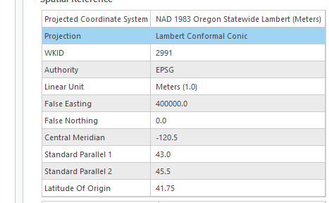

**Chapter 5**

**1. Create a new project for the chosen state, saving it in the gisclass\ClassProjects folder.**

Screenshot:



**2. Open a new map and set the coordinate system to the most appropriate State Plane zone in the State Plane > NAD 1983 (meters) folder. If there is more than one zone for the state, just pick one, preferably the central one.**

Screenshot:

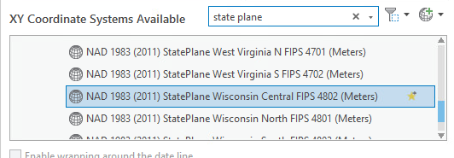

**4. Export each of the vector feature classes from the usdata geodatabase to the new state geodatabase, taking care to export only the features in the state.**

Screenshot:

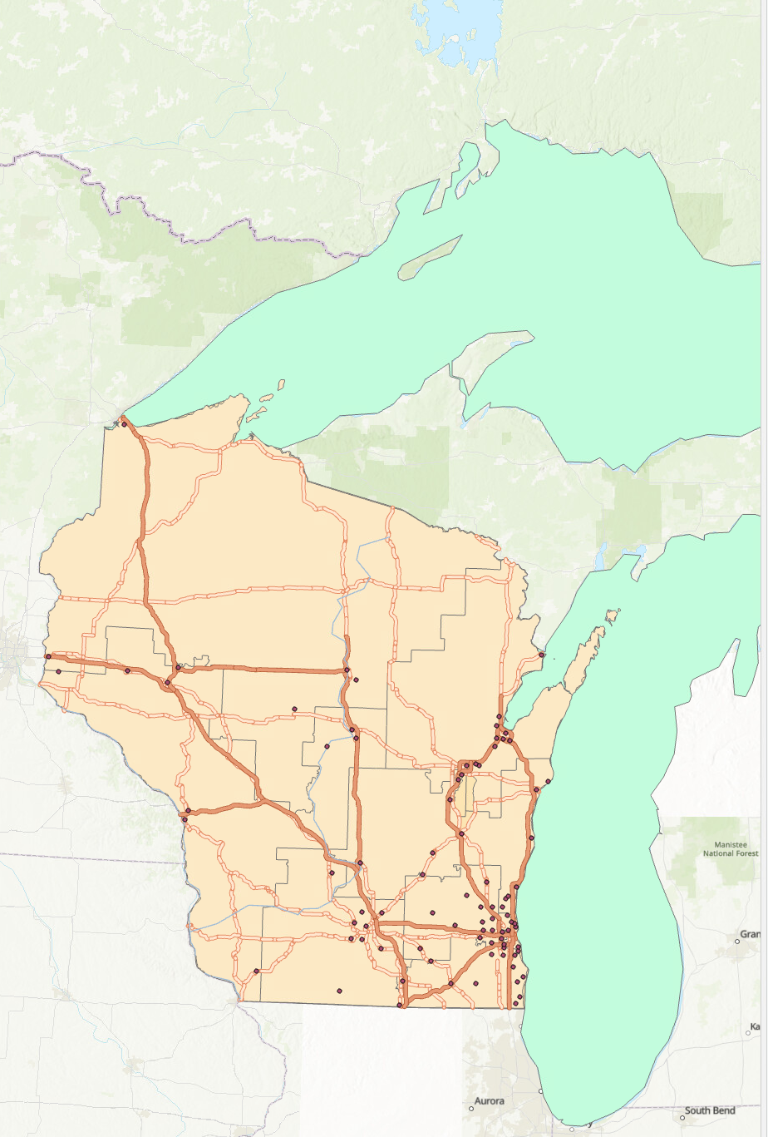

**5. Update the Item Description for each data set exported.**

Screenshot:

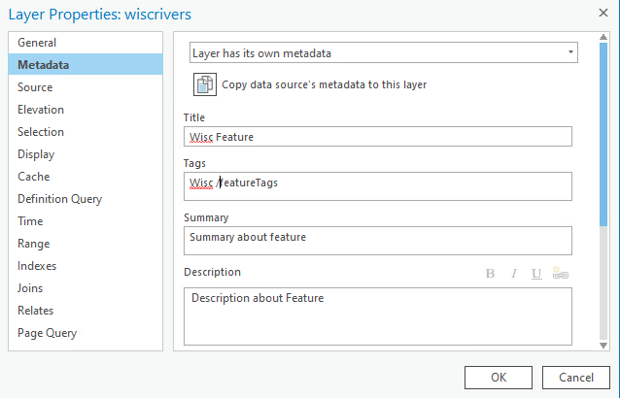

8b.  **A screenshot of the Layers folder in the map properties (as in Fig. 5.20) to show that all layers are in the same coordinate system**